Create Schaefer2018 Atlases for JER’s Child Templates
Step 1. Download the Schaefer atlases from its web: https://github.com/ThomasYeoLab/CBIG/tree/master/stable_projects/brain_parcellation/Schaefer2018_LocalGlobal. The atlases for FreeSurfer can be found under the following path: Parcellations/FreeSurfer5.3/fsaverage/label/. You could copy the atlases that you would like to use (e.g., “lh.Schaefer2018_100Parcels_7Networks_order.annot” and “rh.Schaefer2018…)to a random folder, e.g., the “Downloads”.

2. open a terminal window, and change the directory to the folder with the target JER child templates, e.g., codes: cd Children/Head/Freesurfer/ANTS5-0Years3T/label/

3. In the terminal window, copy the Freesurfer files and templates (created by JER for each of his template) to the local freesurfer folder. This is because the freesurfer registration program called in the next step will find the reference template (e.g., freesurfer templates for the 5-0Years old) in its “subjects” folder. Codes: cp -a ../ANTS5-0Years3T /usr/local/freesurfer/7.2.0/subjects

4. Use the mri_surf2surf function for registration in the terminal window.
Codes: mri_surf2surf --hemi lh --srcsubject fsaverage --trgsubject ANTS5-0Years3T --sval-annot ~/Downloads/lh.Schaefer2018_100Parcels_7Networks_order.annot --tval ./lh.schaefer2018_5YF.annot

The codes above will register the left hemisphere (lh), and the following codes will register the right hemisphere (rh).

mri_surf2surf --hemi rh --srcsubject fsaverage --trgsubject ANTS5-0Years3T --sval-annot ~/Downloads/rh.Schaefer2018_100Parcels_7Networks_order.annot --tval ./rh.schaefer2018_5YF.annot

5. Import the anatomy of the child’s MRI template
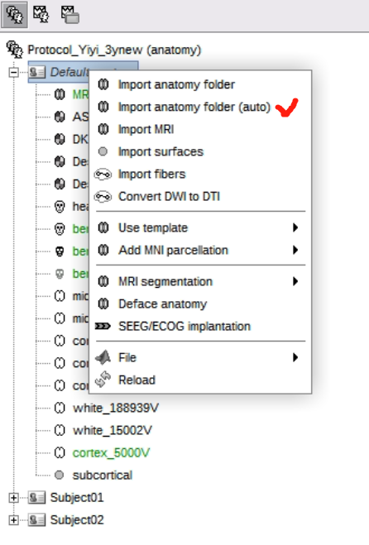

Choose the “Import anatomy folder (auto)”, so brainstorm can automatically load the whole anatomy folder, including a series of subfolders (e.g., “label”, “mri”, “scripts”, etc.). Following this way, the “Schaefer atlases” generated by Freesurfer can be automatically loaded into Brainstorm at the same time.
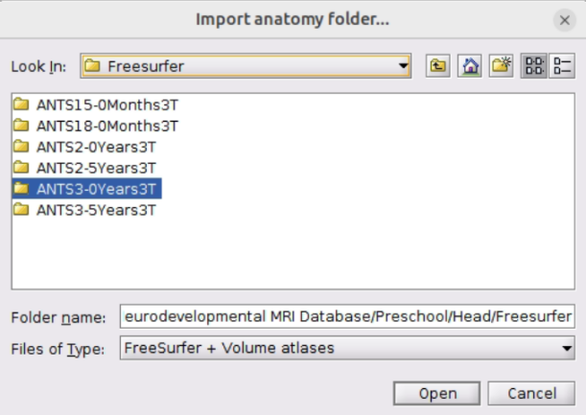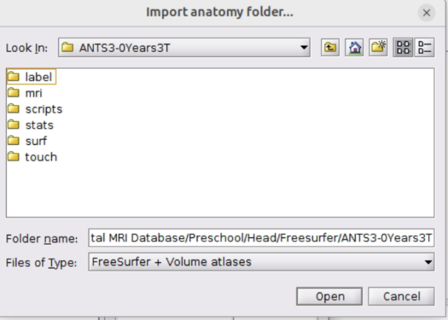
6. Display the cortex
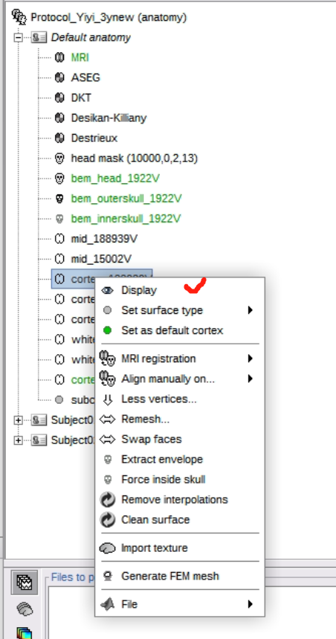
In this step, you can choose the vertex number for the cortex. In the example, we chose the cortex with the most vertices (or you can click “less vertices” to generate a version of 5000 vertices).

7. Display the atlas on the cortex
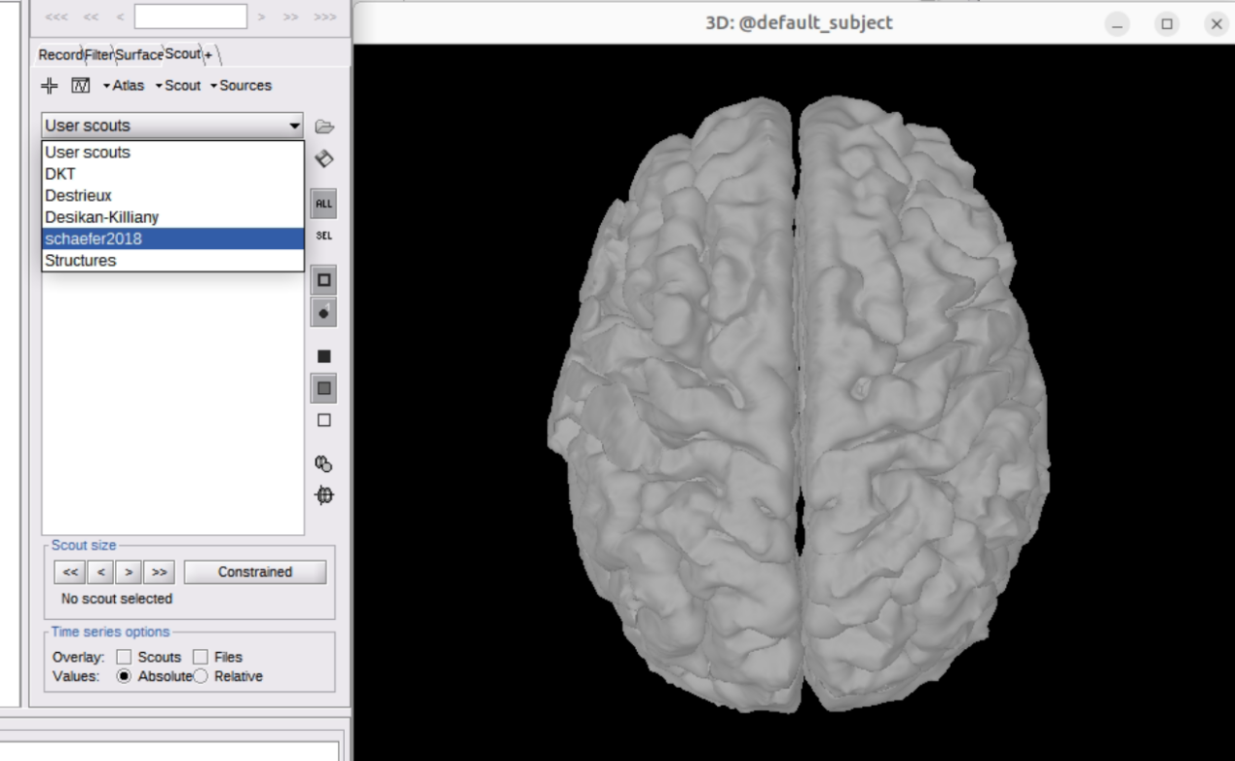
In the display setting window, under the “scout” part, choose the atlas we want to use. Here, we used the atlas we just generated.

The below is the figure with atlas. The first one shows the result on the version of 5000 vertices.
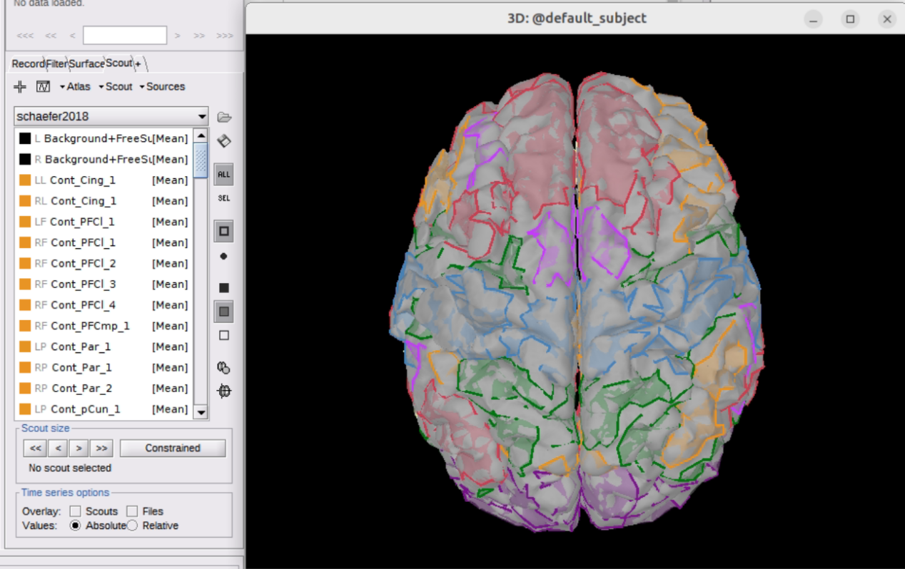

The second one shows the result on the version of more than 180000 vertices. The more vertices you have, the more fined ROI distribution you can get.
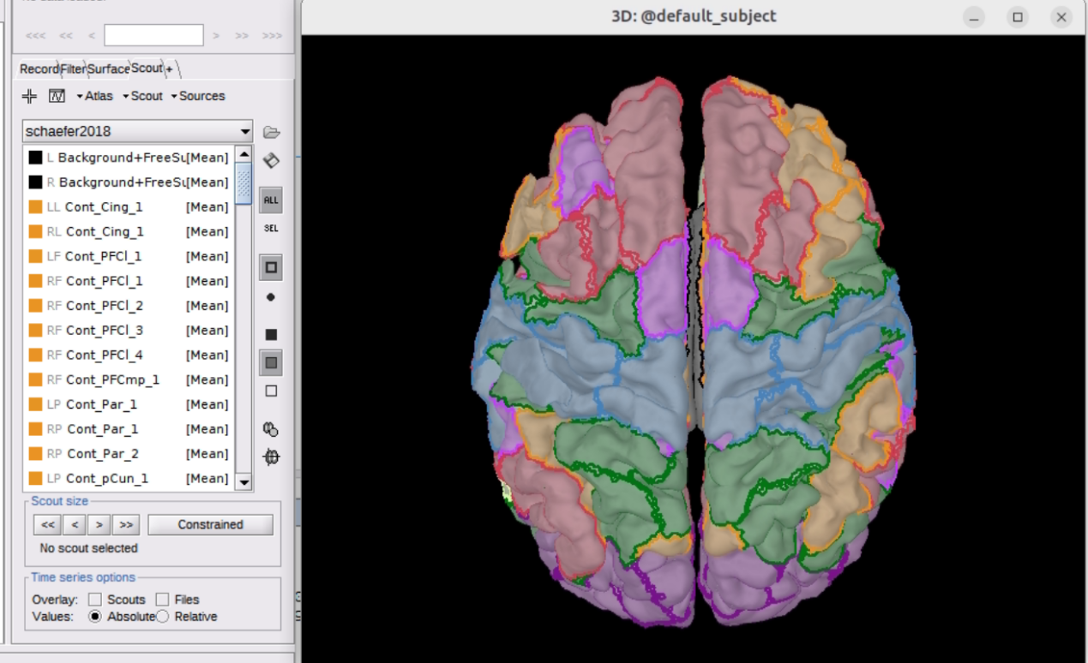

8. Export the scouts which includes the information of which vertices are in which ROI, so you can make further analysis based on ROI.
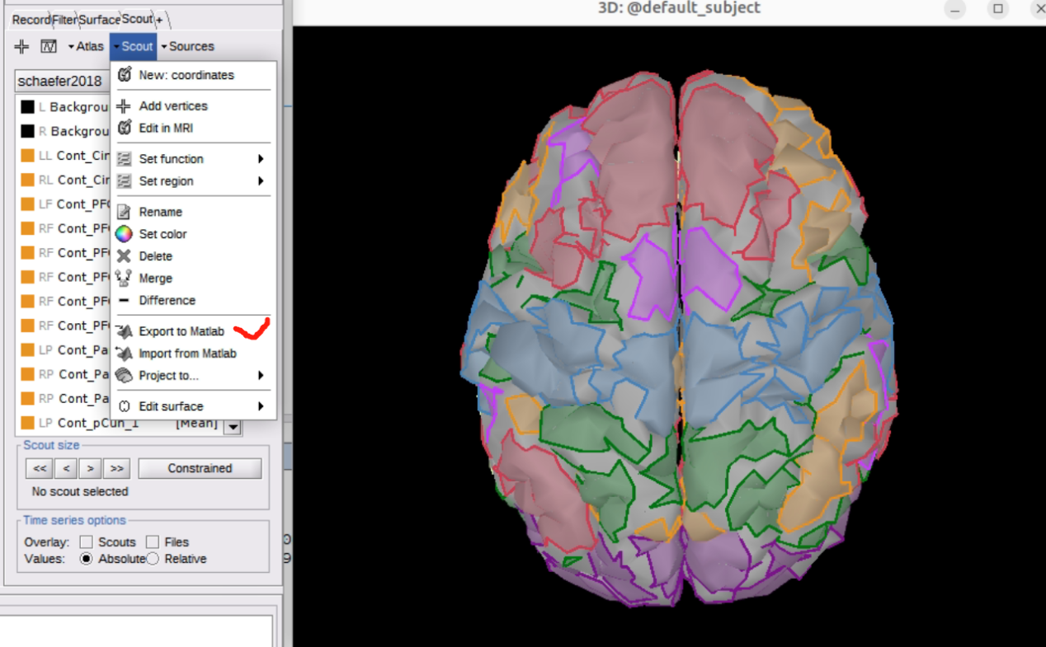

In our example, we named the scout structure as “schaefer2018”. Then, you can find the vertex information for each ROI in the “schaefer2018” window.
